JAVA MultiThreading

Java Multithreading
Multithreading in Java is a process of executing multiple threads simultaneously.
A thread is a lightweight sub-process, the smallest unit of processing. Multiprocessing and multithreading, both are used to achieve multitasking
Java Multithreading is mostly used in games, animation, etc.
Multithreading | Multiprocessing
Uses a shared memory area. | Allocates separate memory areas.
Saves memory. | Consumes more memory.
Context-switching between threads takes less time. | Context-switching between processes takes more time.

✅ Advantages of Multithreading in Java
- Non-blocking → Even if one thread throws an error, the other threads continue running properly.
- Saves time → Multiple tasks can run at the same time, reducing total execution time.
- Performance boost → On a multi-core CPU, different threads can run on separate cores, improving speed.
- Responsive GUI → The user interface doesn’t freeze because background threads handle long-running tasks.
- Shared memory → All threads within a process share the same memory, making communication easier.
- Simpler design → Large tasks can be divided into smaller threads, which makes programs more modular and easier to manage.
- Better CPU utilization → The CPU doesn’t stay idle; it keeps executing available threads, making full use of resources.

Multitasking:
Multitasking is a process of executing multiple tasks simultaneously. We use multitasking to utilize the CPU. Multitasking can be achieved in two ways:
- Process-based Multitasking (Multiprocessing)
- Thread-based Multitasking (Multithreading)
Feature | Process-based Multitasking (Multiprocessing) | Thread-based Multitasking (Multithreading)
Memory | Each process has its own separate memory space | Threads share the same memory space of the process
Weight | A process is heavyweight | A thread is lightweight
Communication | Cost of communication between processes is high (requires IPC like pipes, sockets, etc.) | Cost of communication between threads is low (shared memory, easy data exchange)
Switching | Switching between processes is slower (requires saving/loading registers, memory maps, updating PCB, etc.) | Switching between threads is faster (only thread control block needs update)
Dependency | Independent of each other | A thread cannot exist without a process (depends on the parent process)

Thread:
A thread is a lightweight subprocess, the smallest unit of processing. It is a separate path of execution.
Threads are independent. If an exception occurs in one thread, it does not affect other threads. It uses a shared memory area.
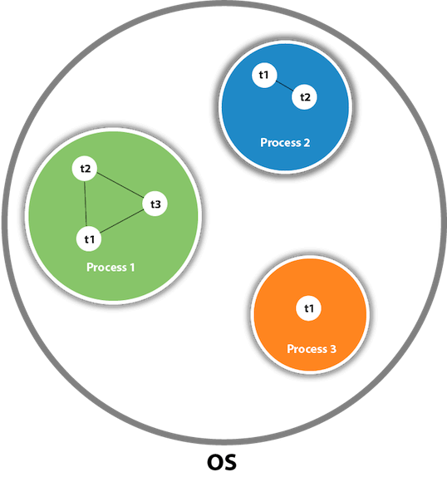
As shown in the above figure, a thread is executed inside the process. There is context-switching between the threads. There can be multiple processes inside the OS, and one process can have multiple threads.

Note: At a time, one thread is executed.

Thread Class
The Thread class provides constructor and methods to create and perform operations on a thread. Thread class extends the Object class and implements the Runnable interface.

Thread States
New: A thread that has been created but not yet started.
Runnable or Running: A thread that is ready to run and waiting for CPU time.
Waiting: A thread that is waiting indefinitely for another thread to perform a particular action.
Terminated: A thread that has completed its task.

Thread Life-Cycle

threads go through several distinct states during their lifetime, as defined in java.lang.Thread.State class. All thread states are Enum constants. A thread can be in only one state at a given point in time.
These states are virtual machine states which do not reflect any operating system thread states.
New --(start())--> Runnable --(CPU schedule)--> Running
^ |
| v
|<----------- Waiting / Timed Waiting / Blocked
|
+----------------------------------> Terminated

Or,
NEW--(start()) --> RUNNABLE--(scheduler picks) --> RUNNING\ / \-- - (finished / error) -- -- -- -- -- -- -- -- -- -- -- -- --> TERMINATED

RUNNING--(wait(), join()) -- -- -- -- -- -- -- -- -- -- -- --> WAITING
RUNNING--(sleep(ms), join(ms), wait(ms)) -- -- -- -- -> TIMED_WAITING
RUNNING--(lock not available) -- -- -- -- -- -- -- -- -- --> BLOCKED

A thread can be in one of the following states:
Thread States | Description
NEW | A thread that has not yet started is in this state.
RUNNABLE | A thread executing in the Java virtual machine is in this state.
BLOCKED | A thread that is blocked waiting for a monitor lock is in this state.
WAITING | A thread that is waiting indefinitely for another thread to perform a particular action is in this state.
TIMED_WAITING | A thread that is waiting for another thread to perform an action for up to a specified waiting time is in this state.
TERMINATED | A thread that has exited is in this state.

Thread States
• NEW
- Thread is created (new Thread()), but start() not called yet.
- Not alive, not scheduled.
• RUNNABLE
- After calling start(), the thread is ready to run.
- May be running or waiting in the runnable queue.
- Scheduler decides which one runs.
• RUNNING
- Sub-state of RUNNABLE (when CPU is assigned).
- Most common transitions: RUNNABLE ↔ RUNNING.
• BLOCKED
- Waiting to acquire a lock (e.g., trying to enter a synchronized block already held by another thread).
- Consumes no CPU until lock is free.
• WAITING
- Waiting indefinitely for another thread’s signal.
- Example: join() without timeout, wait() without timeout.
- Needs notify() / notifyAll() (or joined thread to finish) to continue.
• TIMED_WAITING
- Waiting for a specific time, then resumes automatically.
- Examples: sleep(ms), join(timeout), wait(timeout), parkNanos, parkUntil.
• TERMINATED
- Thread has finished or exited due to exception.
- Dead, cannot be restarted.

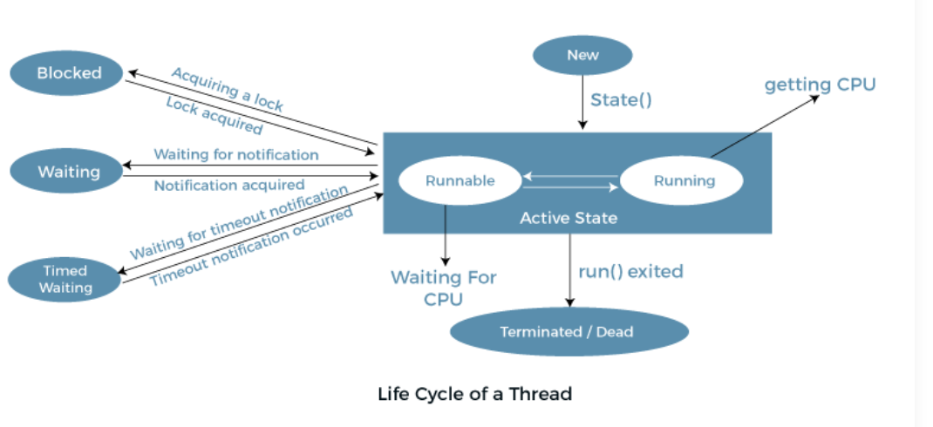

Transitions Between States
- new → start() → runnable

runnable → scheduler picks → running
- running → wait()/join() → waiting
- running → sleep()/join(timeout) → timed waiting
- running → blocked → when trying to acquire a lock
- any state → finished/error → terminated

Thread Class
Threads are lightweight processes that run within the context of a larger process, enabling efficient utilization of system resources and enhancing application responsiveness
threads can be created either by extending the Thread class or by implementing the Runnable interface.
- The Thread class provides built-in support for multithreading.
- The Runnable interface defines a single method, run(), which contains the code that the thread will execute.
By implementing the Runnable interface, we separate the definition of the task from the thread itself. This decoupling leads to better code organization, flexibility, and reusability, since the same task can be executed by different threads without rewriting the logic.

Thread Class
Thread class provide constructors and methods to create and perform operations on a thread. Thread class extends Object class and implements Runnable interface.

By Implementing Runnable Interface
Another approach to creating threads in Java is by implementing the Runnable interface. The Runnable interface should be implemented by any class whose instances are intended to be executed by a thread. Runnable interface have only one method named run(). This approach is preferred when we want to separate the task from the thread itself, promoting better encapsulation and flexibility.
public void run(): is used to perform action for a thread.

Starting a Thread
The start() method of the Thread class is used to start a newly created thread. It performs the following tasks:
- A new thread starts (with new callstack).
- The thread moves from New state to the Runnable state.
- When the thread gets a chance to execute, its target run() method will run.

Example:
1  2  3  4  5  6  7  8  9  10  11 | class Multi3 implements Runnable {  public void run() {  System.out.println("thread is running...");  }  public static void main(String args[]) {  Multi3 m1 = new Multi3();  Thread t1 = new Thread(m1); // Using the constructor Thread(Runnable r)  t1.start();  }  }
Output:
thread is running...

main thread
│
├── Step 1: new Multi3() → m1 object তৈরি
│
├── Step 2: new Thread(m1) → t1 thread object তৈরি (Runnable task attach)
│
├── Step 3: t1.start() → JVM নতুন thread তৈরি করে
│
└── Step 4: নতুন thread → m1.run() execute করে
→ Output: "thread is running..."

In this example, we define a class MyRunnable that implements the Runnable interface and provides the task logic inside its run() method. We then create a new Thread object, passing an instance of MyRunnable to its constructor, and start the thread using the start() method.
If we are not extending the Thread class, the class object would not be treated as a thread object. So, we need to explicitly create the Thread class object. We are passing the object of our class that implements Runnable so that the class's run() method may execute.

Thread Scheduler
A component of Java that decides which thread to run or execute and which thread to wait is called a thread scheduler. A thread is only chosen by a thread scheduler if it is in the runnable state. However, if there is more than one thread in the runnable state, it is up to the thread scheduler to pick one of the threads and ignore the other ones. There are some criteria that decide which thread will execute first.
There are two factors for scheduling a thread i.e. Priority and Time of arrival.
Priority: Priority of each thread lies between 1 to 10. If a thread has a higher priority, it means that thread has got a better chance of getting picked up by the thread scheduler.
- 1 = MIN_PRIORITY, 5 = NORM_PRIORITY (default), 10 = MAX_PRIORITY
Time of Arrival: Suppose two threads of the same priority enter the runnable state, then priority cannot be the factor to pick a thread from these two threads. In such a case, arrival time of thread is considered by the thread scheduler. A thread that arrived first gets the preference over the other threads.

Thread Scheduler Algorithms

First Come First Serve Scheduling:
- This scheduler picks the threads thar arrive first in the runnable queue.

Time-slicing scheduling:
- Usually, the First Come First Serve algorithm is non-preemptive, which is bad as it may lead to infinite blocking (also known as starvation).
- To avoid that, some time-slices are provided to the threads so that after some time, the running thread has to give up the CPU.
- Thus, the other waiting threads also get time to run their job.

Preemptive-Priority Scheduling:
- This algorithm is related to the priority of the threads.
- If there are multiple threads available in the runnable state. The thread scheduler picks that thread that has the highest priority.
- Since the algorithm is also preemptive, therefore, time slices are also provided to the threads to avoid starvation.
- Thus, after some time, even if the highest priority thread has not completed its job, it has to release the CPU because of preemption.

Working of the Java Thread Scheduler:
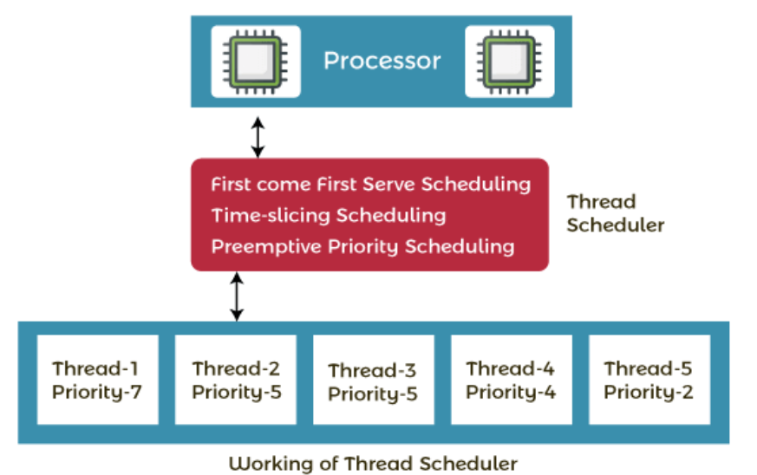
Let's understand the working of the Java thread scheduler. Suppose, there are five threads that have different arrival times and different priorities. Now, it is the responsibility of the thread scheduler to decide which thread will get the CPU first.
The thread scheduler selects the thread that has the highest priority, and the thread begins the execution of the job. If a thread is already in runnable state and another thread (that has higher priority) reaches in the runnable state, then the current thread is pre-empted from the processor, and the arrived thread with higher priority gets the CPU time.
When two threads (Thread 2 and Thread 3) having the same priorities and arrival time, the scheduling will be decided on the basis of FCFS algorithm. Thus, the thread that arrives first gets the opportunity to execute first.

Thread.sleep()
The Thread.sleep() method is a static method of the Thread class that causes the currently executing thread to sleep (pause its execution) for a specified number of milliseconds.
Thread class provides the two variants of the sleep() method. First one accepts only an argument, whereas the other variant accepts two arguments.

Syntax:
public static void sleep(long mls) throws InterruptedException
public static void sleep(long mls, int n) throws InterruptedException

The method sleep() is being used to halt(থামা) the working of a thread for a given amount of time. The time up to which the thread remains in the sleeping state is known as the sleeping time of the thread. After the sleeping time is over, the thread starts its execution from where it has left.
sleep(long millis):
- This is a native method.
- Its actual implementation is not written in Java but in another programming language (like C/C++).
- The JVM uses this native code to put the thread to sleep.
sleep(long millis, int nanos):
- This is a non-native method.
- Its implementation is written in Java.
- Internally, this method calls the single-parameter sleep(millis) method.
🔹 Common Points
- Both methods are static, which means they are always accessed with the class name: Thread.sleep().
- Both throw a checked exception: InterruptedException.

🔹 Parameters of sleep() Method
- mls (milliseconds)
  - Represents the duration (in milliseconds) for which the thread will sleep.
  - Example: Thread.sleep(2000) → the thread pauses for 2 seconds.
- n (nanoseconds)
  - Represents additional time in nanoseconds.
  - The range is 0 to 999,999 (less than 1 millisecond).
  - Example: Thread.sleep(1000, 500000) → the thread sleeps for 1 millisecond + 500,000 nanoseconds (0.5 ms).
Both parameters are used in the method:
public static void sleep(long mls, int n) throws InterruptedException

🔹 Return Type
- The sleep() method does not return anything (void).

🔹 Important Points to Remember
- Always halts the current thread
  - When Thread.sleep() is called, it pauses the currently running thread for the given time.
- InterruptedException
  - If another thread interrupts the current thread while it is sleeping, an InterruptedException will be thrown.
- Actual sleep time may vary
  - If the system is busy (heavy CPU load), the actual sleep time may be longer than the time specified.
  - If the system is less loaded, the sleep duration is usually close to the specified time.
Example:
1  2  3  4  5  6  7  8  9  10  11 | public class SleepExample {  public static void main(String[] args) {  System.out.println("Start");  try {  Thread.sleep(2000); // Pause for 2000 milliseconds (2 seconds)  } catch (InterruptedException e) {  System.out.println("Thread interrupted");  }  System.out.println("End");  }  }
Important Example:
- public class InterruptHandling {
- public static void main(String[] args) {
- Thread thread = new Thread(() -> {
- try {
- System.out.println("Thread will sleep for 5 seconds.");
- Thread.sleep(5000);
- System.out.println("Thread woke up after sleep.");
- } catch (InterruptedException e) {
- System.out.println("Thread was interrupted during sleep.");
- }
- });
- thread.start();
- try {
- Thread.sleep(2000); // Main thread sleeps for 2 seconds
- thread.interrupt(); // Interrupt the sleeping thread
- } catch (InterruptedException e) {
- e.printStackTrace();
- }
- }
- }
Output:
Thread will sleep for 5 seconds.
Thread was interrupted during sleep.

Note: As you know well that at a time only one thread is executed. If you sleep a thread for the specified time, the thread scheduler picks up another thread and so on.

The exception IllegalArguementException when the time for sleeping is negative.
Example:
// important import statements
import java.lang.Thread;
import java.io.*;

public class TestSleepMethod3 {
// main method
public static void main(String argvs[]) {
// we can also use throws keyword followed by
// exception name for throwing the exception
try {
for (int j = 0; j < 5; j++) {

// it throws the exception IllegalArgumentException
// as the time is -ive which is -100
Thread.sleep(-100);

// displaying the variable's value
System.out.println(j);
}
} catch (Exception expn) {

// the exception iscaught here
System.out.println(expn);
}
}
}

Output:
java.lang.IllegalArgumentException: timeout value is negative

start a thread twice

Can we start a thread twice
No. After starting a thread, it can never be started again. If we does so, an IllegalThreadStateException is thrown. In such case, thread will run once but for second time, it will throw exception.
Example:

public class TestThreadTwice1 extends Thread {
public void run() {
System.out.println("running...");
}
public static void main(String args[]) {
TestThreadTwice1 t1 = new TestThreadTwice1();
t1.start();
t1.start();
}
}

Output:
running
Exception in thread "main" java.lang.IllegalThreadStateException

calling run() method

What if we call Java run() method directly instead start() method?
- Each thread starts in a separate call stack.
- Invoking the run() method from the main thread, the run() method goes onto the current call stack rather than at the beginning of a new call stack.

🔹 Difference between start() vs run() in Java

1. start() method
- নতুন thread তৈরি করে।
- JVM কে বলে: “এই Thread object-এর জন্য আলাদা call stack বানাও, তারপর এর run() চালাও।”
- ফলে concurrent execution হয় (main thread + new thread একসাথে চলে)।
Example:
MyThread t = new MyThread();
t.start(); // ✅ creates a new thread

2. run() method
- এটা স্রেফ একটা সাধারণ method call মাত্র।
- কোনো নতুন thread তৈরি করে না।
- ওই method current thread-এর call stack এ execute হবে।

Example:
MyThread t = new MyThread();
t.run(); // ❌ just a normal method call, no new thread

Example:
class MyThread extends Thread {
public void run() {
System.out.println("Running in: " + Thread.currentThread().getName());
}

public static void main(String[] args) {
MyThread t1 = new MyThread();

// Case 1: start()
t1.start(); // prints: Running in: Thread-0

// Case 2: run()
t1.run(); // prints: Running in: main
}
}

🔹 Output Explanation
- t1.start(); → আলাদা Thread-0 তৈরি হবে।
- t1.run(); → current thread ("main") এ execute হবে।
✅ Conclusion:
- start() → নতুন thread (new call stack)।
- run() → সাধারণ method call (same call stack, no new thread)।

Problem if you direct call run() method

class TestCallRun2 extends Thread {
public void run() {
for (int i = 1; i < 5; i++) {
try {
Thread.sleep(500);
} catch (InterruptedException e) {
System.out.println(e);
}
System.out.println(i);
}
}
public static void main(String args[]) {
TestCallRun2 t1 = new TestCallRun2();
TestCallRun2 t2 = new TestCallRun2();

t1.run();
t2.run();
}
}

Output:
1
2
3
4
1
2
3
4

As we can see in the above program that there is no context-switching because here t1 and t2 will be treated as normal object not thread object.

joining() threads
• Definition: The join() method in the Thread class allows one thread to pause its execution until another thread has completed.
• Working: Suppose t1 is a thread, and in the main thread we write t1.join();. This means the main thread will wait until t1 finishes execution.
• Overloaded Methods:
- join() → Waits until the thread finishes execution.
Syntax:
public final void join() throws InterruptedException
- join(long millis) → Waits for the specified time in milliseconds, or returns earlier if the thread finishes before that.
Syntax:
public final synchronized void join(long mls) throws InterruptedException, where mls is in milliseconds

- join(long millis, int nanos) → Waits with more precision (milliseconds + nanoseconds).
Syntax:
public final synchronized void join(long mls, int nanos) throws InterruptedException, where mls is in milliseconds.

• Exception: If a thread is interrupted while waiting, the join() method throws an InterruptedException.
• Important Points:
- join() helps control the execution order in multi-threaded programs.
- Like sleep(), the timing of join() depends on the operating system, so join(1000) does not guarantee an exact 1-second wait.

Important Example:
1  2  3  4  5  6  7  8  9  10  11  12  13  14  15  16  17  18  19  20  21  22  23  24  25  26 | class TestJoinMethod2 extends Thread {  public void run() {  for (int i = 1; i <= 5; i++) {  try {  Thread.sleep(500);  } catch (Exception e) {  System.out.println(e);  }  System.out.println(i);  }  }  public static void main(String args[]) {  TestJoinMethod2 t1 = new TestJoinMethod2();  TestJoinMethod2 t2 = new TestJoinMethod2();  TestJoinMethod2 t3 = new TestJoinMethod2();  t1.start();  try {  t1.join(1500);  } catch (Exception e) {  System.out.println(e);  }  t2.start();  t3.start();  }  }

Output:
1
2
3
1
4
1
2
5
2
3
3
4
4
5
5
- এখন main থ্রেড অপেক্ষা করছে সর্বোচ্চ 1500 ms (মানে 1.5 সেকেন্ড) t1 এর কাজ শেষ হওয়ার জন্য।
- কিন্তু t1 পুরো কাজ শেষ করতে সময় নেবে 5 × 500 ms = 2500 ms (2.5 সেকেন্ড)।
- তাই 1500 ms পর main থ্রেড আর অপেক্ষা করবে না → main এগিয়ে যাবে।
- শেষ পর্যন্ত তিনটা থ্রেড একসাথে চললো আর প্রিন্ট interleaved হলো।

Naming Thread and Current Thread

Naming Thread
The Thread class provides methods to change and get the name of a thread. By default, each thread has a name, i.e. thread-0, thread-1 and so on. By we can change the name of the thread by using the setName() method. The syntax of setName() and getName() methods are given below:
- public String getName(): is used to return the name of a thread.
- public void setName(String name): is used to change the name of a thread.
We can also set the name of a thread directly when we create a new thread using the constructor of the class.
- ThreadName th1 = new ThreadName("JavaTpoint1");

Thread Priority
Definition:
Each thread in Java has a priority represented by a number between 1 and 10.
Normally, the thread scheduler uses these priorities to decide the order of execution (called preemptive scheduling).
However, this is not guaranteed — it depends on the JVM implementation.
Setter & Getter Methods:
- public final int getPriority()
→ Returns the priority of a thread.
- public final void setPriority(int newPriority)
→ Sets the priority of a thread.
- Throws IllegalArgumentException if the value is not between 1 and 10.
Thread Priority Constants (defined in the Thread class):
- public static int MIN_PRIORITY = 1
- public static int NORM_PRIORITY = 5 (default priority)
- public static int MAX_PRIORITY = 10
Default Priority:
- Every new thread has a default priority of 5 (NORM_PRIORITY).

We know that a thread with high priority will get preference over lower priority threads when it comes to the execution of threads. However, there can be other scenarios where two threads can have the same priority. All of the processing, in order to look after the threads, is done by the Java thread scheduler.
If there are two threads that have the same priority, then one can not predict which thread will get the chance to execute first. The execution then is dependent on the thread scheduler's algorithm (First Come First Serve, Round-Robin, etc.)

Daemon Thread
Definition:
A daemon thread is a background service thread in Java that provides support to user threads. Its life depends entirely on user threads—once all user threads finish, the JVM automatically terminates daemon threads.
Examples:
Common JVM daemon threads include Garbage Collector (gc) and Finalizer.
Key Points to Remember:
- Provides background services to user threads.
- Has no independent role other than serving user threads.
- Always low priority compared to user threads.
- JVM kills daemon threads automatically when no user thread is running (since their purpose is only to support user threads).
Why JVM Terminates Daemon Threads?
If no user thread is alive, there is no reason for background support. Hence, JVM terminates daemon threads to free resources.
Methods from Thread Class:
- public void setDaemon(boolean status)
→ Marks a thread as daemon or user thread.
- public boolean isDaemon()
→ Checks if a thread is daemon.

Note:

If you want to make a user thread a daemon thread, you must call setDaemon(true) before starting the thread.
Once a thread has been started, attempting to change it to a daemon thread will result in an IllegalThreadStateException.

Thread Pool
• Definition:
A Thread Pool in Java is a collection of reusable worker threads. Instead of creating a new thread for every task, a thread pool manages a fixed number of threads that can be reused for multiple jobs.
• Working:
- A fixed number of threads are created in advance.
- When a job arrives, one thread from the pool is assigned to execute it.
- After completing the job, the thread returns to the pool and becomes available for the next task.
• Executor Framework Methods (Executors class):
- newFixedThreadPool(int s)
→ Creates a thread pool of fixed size s.
- newCachedThreadPool()
→ Creates a thread pool that grows as needed; reuses previously created threads if available.
- newSingleThreadExecutor()
→ Creates a thread pool with only one thread.
• Advantages:
- Better Performance: Saves time by reusing existing threads (no overhead of creating new ones).
- Resource Management: Controls the number of active threads, preventing system overload.
• Real-Time Usage:
- Widely used in Servlets and JSP containers, where a thread pool is created to handle multiple client requests efficiently.

